Name: ___________________________________ Date: ______________________ Period: _______

**Answer Key**

# Independent Practice: Punnett Squares

Complete the table below using the information provided to the left, and then complete each of the Punnett squares and their accompanying questions.



**pp white flowers**

**Tt tall**

**ss wrinkled peas**

**Pp purple flowers**

**ss short**

**TT tall**

**SS smooth peas**

**Ss smooth peas**

**T**

**t**

**T t**

Tt × Tt

**1. What percentage of the offspring will have a tall phenotype? __________**

**2. What percentage of the offspring will have a homozygous recessive genotype? __________**

**3. What percentage of the offspring will have long beaks? __________**

**4. What percentage of the offspring will have a heterozygous genotype? __________**

LL × Ll

**5. What percentage of the offspring will have a homozygous dominant genotype? __________**

**6. What percentage of the offspring will have white eyes (dd)? __________**

Dd × Dd

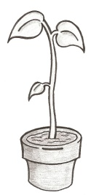

**Long beak**

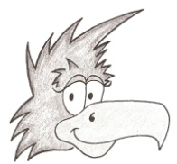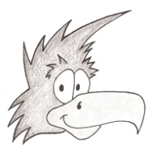

**Dark eyes**

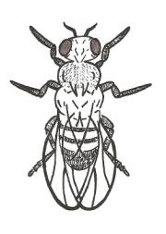

**Tall**

**Tall**

**75%**

**TT**

**Tt**

**Tt**

**tt**

**25%**

**L l**

**L**

**l**

**Long beak**

**75%**

**DD**

**Dd**

**Dd**

**dd**

**LL**

**Ll**

**Ll**

**ll**

**50%**

**D d**

**D**

**d**

**Dark eyes**



**25%**

**25%**

**P p**

**p**

**p**

**7. What percentage of the offspring will have purple flowers as their phenotype? __________**

**8. What percentage of the offspring will have a heterozygous genotype? __________**

**White flowers**

**Purple flowers**

Pp × pp

**50%**

**Pp**

**pp**

**Pp**

**pp**

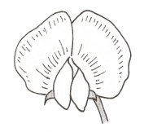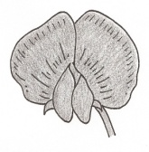

**50%**

**D d**

**White eyes**

**9. What percentage of the offspring will have a heterozygous genotype? __________**

**10. What percentage of the offspring will have white eyes? __________**

**Dark eyes**

Dd × dd

**d**

**d**

**Dd**

**dd**

**Dd**

**dd**

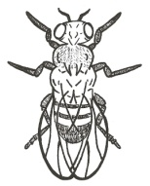

**50%**

**50%**

**T t**

**T**

**t**



**Tall**

**Tall**

**11. What percentage of the offspring will be short? __________**

**12. What percentage of the offspring will have a tall phenotype? __________**

Tt × Tt

**25%**

**TT**

**Tt**

**Tt**

**tt**

**75%**

**G G**

**13. What percentage of the offspring will have the phenotype of gray hair? __________**

**14. What percentage of the offspring will have a homozygous recessive genotype? __________**

**White fur**

**Gray fur**

GG × gg

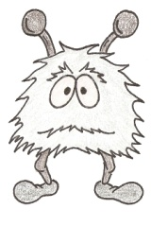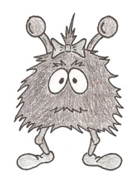

**100%**

**g**

**g**

**Gg**

**Gg**

**Gg**

**Gg**

**Ll**

**ll**

**Ll**

**ll**

**0%**

**L l**

**15. What percentage of the offspring will have long beaks? __________**

**16. What percentage of the offspring will have a heterozygous genotype? __________**

**Short beak**

**Long beak**

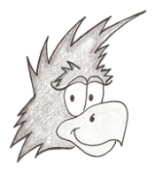

Ll × ll

**50%**

**l**

**l**

**50%**

© Haney Science